Jenkins

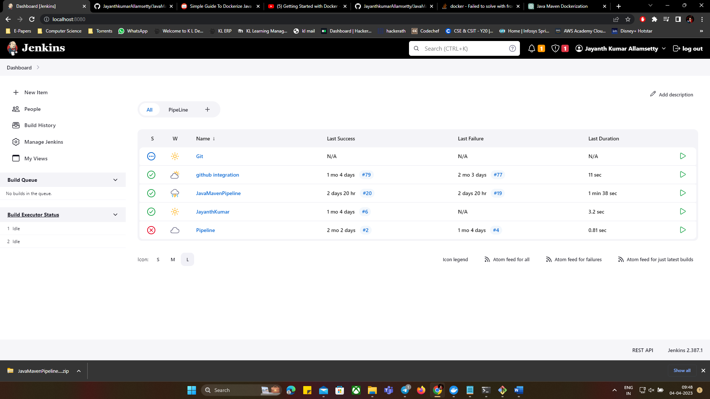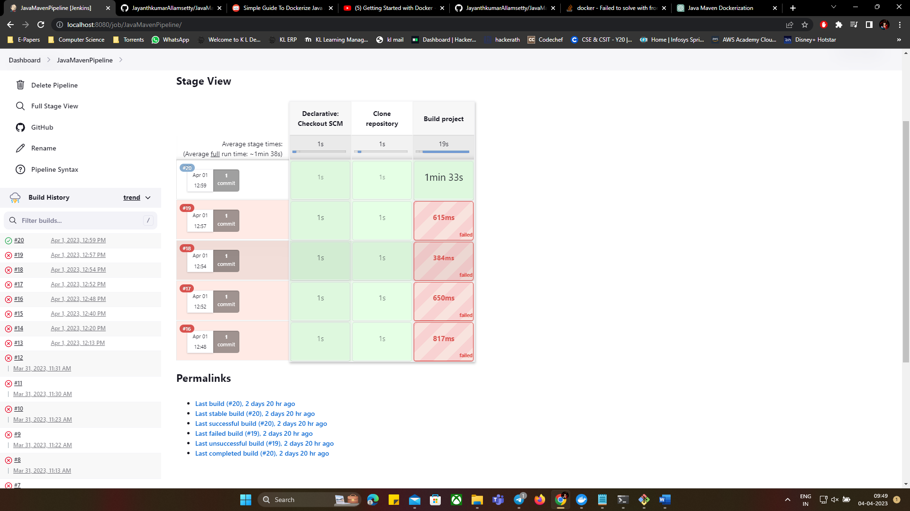

Terraform:

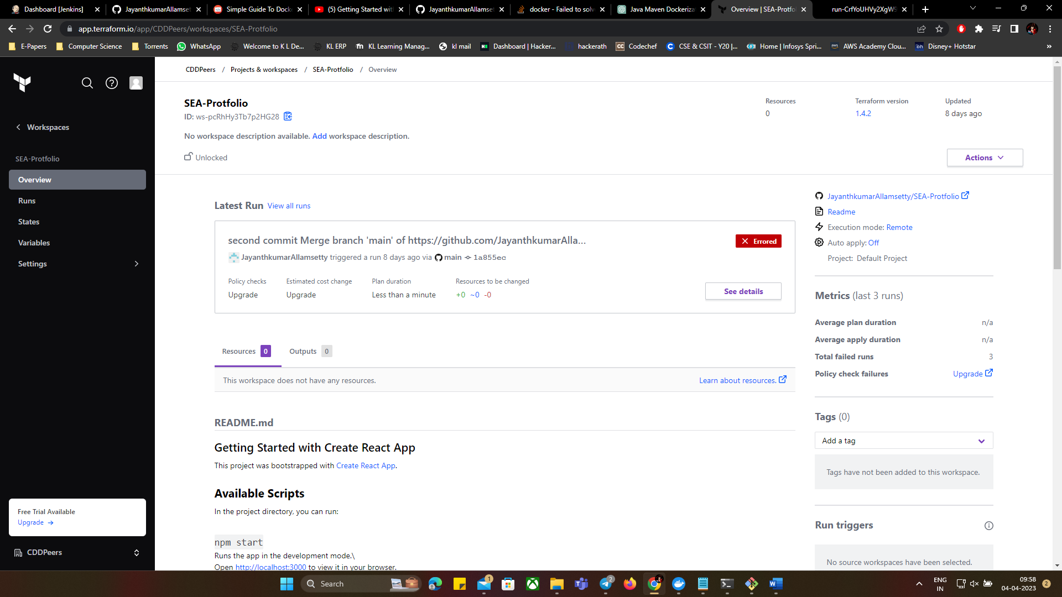

Docker:

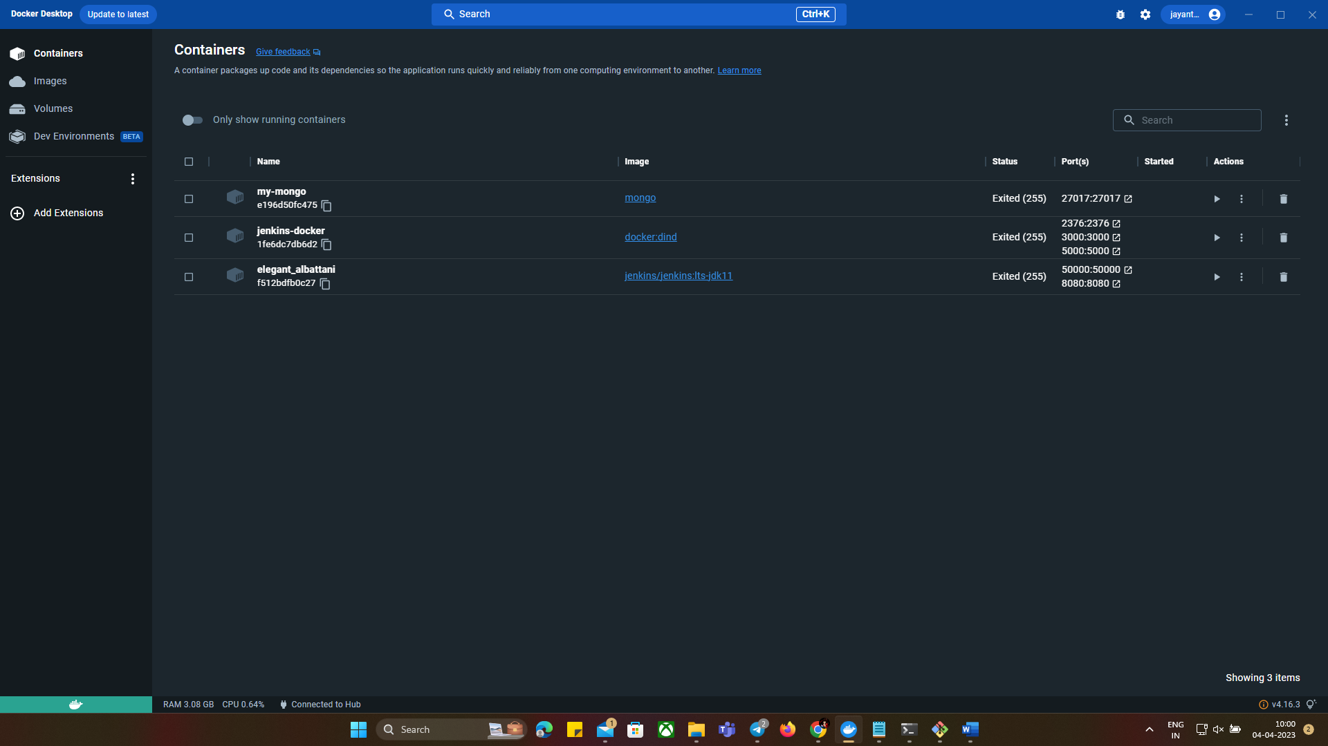

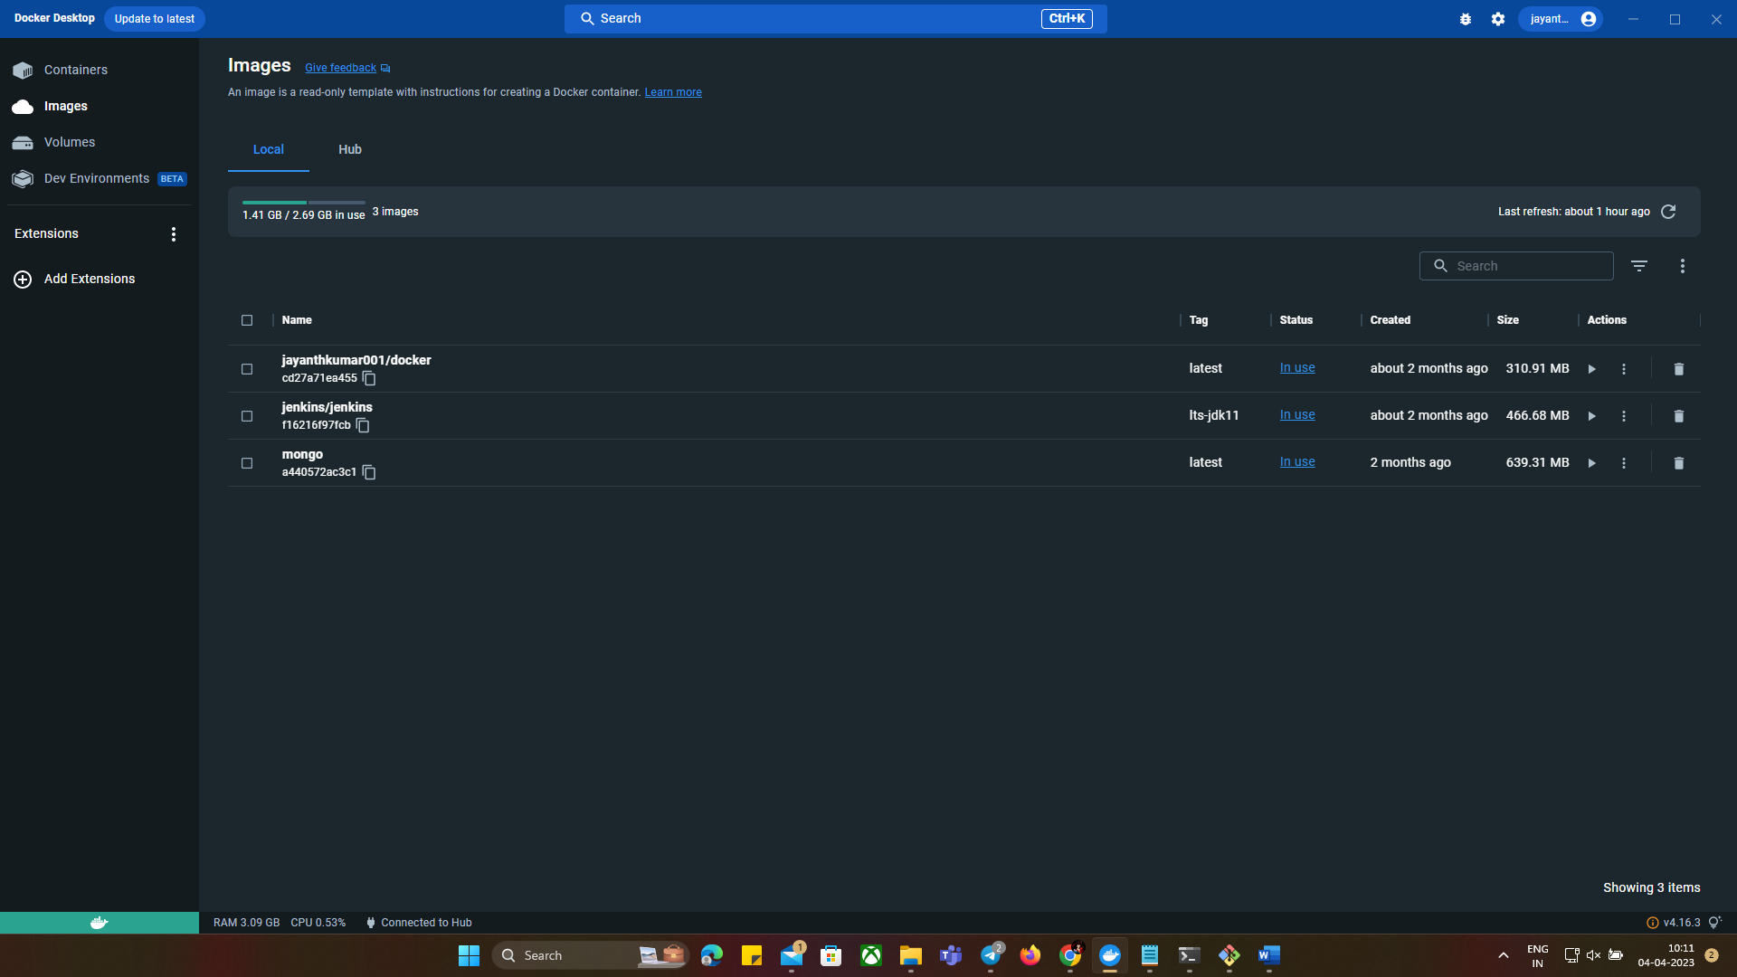

Ansible:



